**Case Study 1**

Chapter 13

**Submitted to:**

Ms. Maria Khan

**Submitted by:**

Hamza Farooq (2016-CS-122)



June, 2020

Chapter # 15

Quiz No. 01

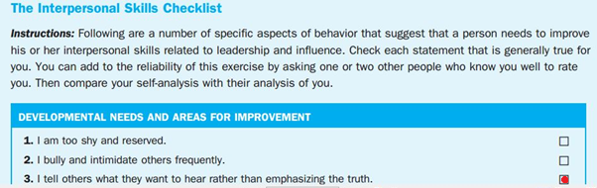

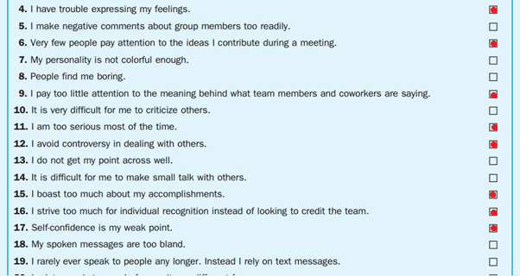

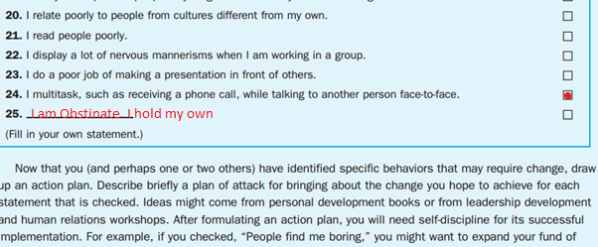

## I am confident when it comes to ideas. I present my points after doing homework on them. I solidify my decisions through precautionary measures and risk analysis.